artspace\backdoor
curated by

proudly presents

Cru Classé Brégançon by Paul Brouwer

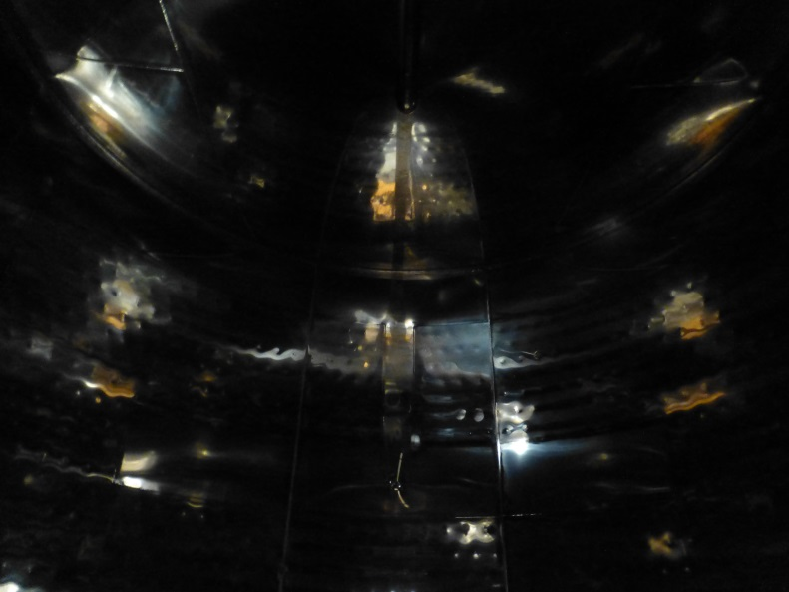

Expo with 12 photo’s from the series Cru Classé Brégançon
19 & 20 December 2020, 13.00 – 17.00 hrs
Wilhelminakade 101, Rotterdam

RSVP

The expo will be on display untill 21 Februari 2021
www.stinkhond.com
www.margreetholsthoorn.com

